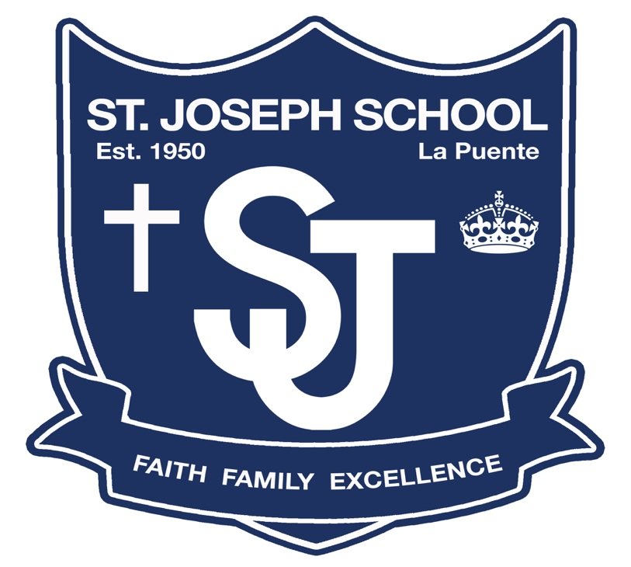

St. Joseph School

2021-22 Parent-Student Handbook

“Instilling a Commitment to Faith, Encouraging the Family Spirit, and Strengthening a Dedication to Excellence”

Dear Parents,

St. Joseph faculty and staff are excited about the possibilities of the new school year and eager to make it great for your children and family. This handbook will familiarize you with our school philosophy, policies, and procedures. As there have been several revisions made and additions from the LA Archdiocese’s Department of Catholic School, we ask that you read it carefully and keep it as a handy reference.

Signature page (p.52) must be turned into your homeroom teacher.

The School Reopening Plan and COVID-19 Policies and Protocols are a separate document than the handbook. That information can be found on the front page of school’s website and under the “Family” tab.
Critical to the success of our students is the dedication our community has toward communication and organizational structure. At St. Joseph School, the parent(s) are the primary educator(s) who are partners with the teachers and administration to ensure the best educational experience for all of St. Joseph students. As strong team members everyone will work together to support the mission of the school, achieve the school wide goals and to develop the whole child.
May God bless your commitment to Catholic Education. We trust that our students will again experience a most rewarding school year, while planting the seeds for a lifetime of success.

Respectfully,

Mr. Ranney

Principal

St. Joseph School

St. Joseph School Vision Statement:
The faculty, staff and administration of St. Joseph School are committed to welcoming, teaching and including everyone as Jesus Christ did. While also having a plan to meet each family where they currently are spiritually, academically, and financially so that they can further develop their relationship with Christ.
St. Joseph School Mission Statement:
Instilling a Commitment to our Catholic Faith, Encouraging the Family Spirit, and Strengthening a Dedication to Academic Excellence. St. Joseph School fosters the development of the whole child to produce purpose driven individuals who demonstrate excellence in character and are faith filled leaders of their community.

St. Joseph School Philosophy:
Saint Joseph School is a Catholic, student-centered learning community that provides a safe 21st century learning environment that includes opportunities for all members of the school community to practice their Catholic faith daily. The curriculum encompasses religion, blended learning environments with small group instruction, project-based learning, and Tier I and II instructional time which is also coupled with fine arts and athletics. This balanced curriculum enables St. Joseph School to develop the whole person in each child – spiritually, intellectually, psychologically, socially, physically, and athletically.
We value the participation of parents and their interests in the education of their children. We believe that parents have the primary responsibility for the education of their children. We realize fully the sacrifice parents make to have their children. Therefore, we take most seriously our privilege and responsibility to educate these children to the best of our ability.
St. Joseph School Chain of Command:
If any questions or concerns should arise regarding your child(ren) please speak to his or her teacher first. Please, email or speak to the teacher directly and immediately. Please also be sure to copy (CC) the principal on the communication. The faculty has 24 business hours to reply to any emails or return phone calls.
If there are still concerns after speaking to the teacher then parents are encouraged to meet with the principal directly. Please, do not go directly to the Pastor or the Archdiocese as they will defer back to the principal so that any school matters can be resolved.
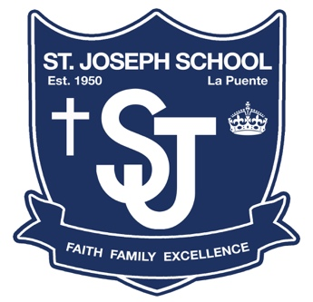
2021-22 School Wide Curriculum Expectations

To begin the 2021-22 school year the faculty and staff will attempt to pinpoint where each student is on their educational path. To close any learning gaps the faculty and staff have been vertical planning for each student since the Spring of 2020.
Formative assessment data, end of the year student portfolios, and teacher feedback will be used to plan instruction, student grouping, small group instruction, differentiation, daily classroom norms, and procedures, as well as the use of various digital platforms.
St. Joseph School will continue to have blended learning environments with small group instruction, project-based learning, and Tier I and II instructional time. The teaching strategies that are implemented will be center on Multi-Tiered Systems of Support (MTSS) and Core Instruction teaching Practices.
The faculty and staff will pride themselves on their organization, preparation, and data driven lesson planning by having lesson plans submitted a week in advance.
The school community will take on a growth Mind Set, remain flexible, and work together to ensure that every student meets their individual goals.
The faculty and parents will work together to ensure that everyone develops the knowledge, skills, and desire necessary to ensure disciplined habits are established.
WASC/WCEA Goals for 2017 to 2024
- Create and use school wide rubrics
- Resources to help improve math and language arts throughout the school
- Faculty development with intervention strategies to help improve student learning
- Develop faith formation opportunities for families
- Upgrade technology access for students

St. Joseph School
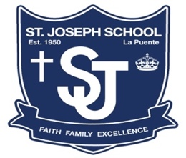
2021-22 School Wide Focus and Goals
FAITH:

- Focus:
  - To Remain Strong in the Face of Tribulation & Love our Neighbor as We Love Ourselves.
- Goals:
  - Students in grades 3 through 8 will complete four Christian Service Hours during the 2021-22 School Year
  - 90% of students demonstrate Mastery in the Pillar of Celebration of Christian Mystery in Liturgy and Sacraments
FAMILY:

- Focus:
  - Excellence in Character, Do Hard Things, & Be Comfortable while Uncomfortable
- Goals:
  - Students will Embody the Royal Etiquette, Leadership Standard & Student Learning Expectations
  - Promote Strong Social Emotional Health & a Healthy & Safe Learning Environment through Mindset, Awareness, Action, & Positive Self-Talk
  - Parents will work with their Children so that they can meet their Individual Accelerated Reader Trimester Goal
EXCELLENCE:

- Focus:
  - Lead with Energy, Effort, Attitude, and Focus daily to develop the knowledge, skills, and desire that are necessary so that disciplined habits are formed
  - Differentiation in a blended learning environment to develop foundational skills in Reading, Writing, Math, & Faith
- Goals:
  - 80% of all students will have a student growth percentage of at least 50% by the end of the 2021-22 school year
  - Each Student will Grow by One Reading Level as Measured by the STAR Instructional Reading Level & at least Ten Percentile Rank points in Math
  - 80% of each class will reach their AR Goal each Trimester
  - Students will complete monthly Science or Social Studies projects
FACULTY & STAFF
EXTRACURRICULAR & ADMINISTRATIVE ASSIGNMENTS
2021-22
Staff Member | Position | Assignments
Mr. Roger Ranney | Principal | Everything
Mrs. Carmen Ramirez | Front Office Manager | - Assists the Principal with Enrolling Students, Financial Aid, Payroll & Deposits  - QuickBooks Entries  - Runs the Front Office  - Health Records  - Emergency Contacts  - Cum Files  - School Speak Administrator  - All Purchasing & Ordering
Ms. Stacy Acuna | 8th Grade Teacher | - Decathlon  - Religion Coordinator  - ACRE Testing  - Altar Servers  - Science Camp  - May Crowning  - Graduation  - Class Retreat  - Class Masses  - Sunday Fundraisers  - Ecology/Science Camp  - St. Matthew (Fr. Cumberland) Feast Day
Ms. Denay Galos | 7th Grade Teacher | - All Saints Day  - Class Retreat  - Class Masses  - Sunday Fundraisers  - School Newspaper  - Ecology/Science Camp
Mr. Mark Padilla | 6th Grade Teacher | - All Saints Day  - Mass Family Work Sheets  - Leading Rosary Prayers  - Christian Service Project Leader  - Class Retreat  - Class Masses  - Sunday Fundraisers  - Ecology/Science Camp
Mrs. Teresa Silva | 5th Grade Teacher | - Art Coordinator  - Art Gallery Walk  - Ecology/Science Camp  - School Newspaper  - Morning Day Care  - Class Retreat  - Class Masses  - Sunday Fundraisers
Mr. Manuel Carmona | 4th Grade Teacher | - Yearbook Coordinator  - Media Arts/Graphic Design  - School Newspaper  - YouTube Channel  - Decathlon  - Class Retreat  - Class Masses  - Sunday Fundraisers
Mrs. Diana Torres | 3rd Grade Teacher | - Folklorico  - Pro-Life Events Coordinator  - Spanish Classes  - Dr. Seuss Day  - Community Helpers Day  - Art Gallery Walk  - Spanish Community Outreach  - Parent-Teacher Conferences  - Class Retreat  - Class Masses  - Sunday Fundraisers
Mrs. Marisela Sahagun | 2nd Grade Teacher | - 1st Communion Program  - Mother Luisita Day  - Religion Outreach Coordinator  - Lost & Found  - Our Lady of Fatima Feast Day  - Accelerated Reading Nights  - Student Birthday’s  - Class Retreat  - Class Masses  - Sunday Fundraisers
Mrs. Laura Sanchez | 1st Grade Teacher | - Mother Luisita Day  - Student Birthday’s  - Ecology  - Class Accelerated Reading Coordinator  - Accelerated Reading Nights  - Class Retreat  - Class Masses  - Sunday Fundraisers
Mrs. Annette Becker | Kindergarten Teacher | - STAR Coordinator  - PlanBook Coordinator  - Cheer  - Parent-Teacher Conferences  - Class Masses  - Sunday Fundraisers
Ms. Desiree Contreras | Transitional Kindergarten Teacher | - Student Council  - Our Lady of Guadalupe Feast Day  - Field Trip Coordinator  - Family Movie Nights  - Homework Club  - Community Helpers Day  - Class Retreat  - Class Masses  - Sunday Fundraisers
Mrs. Lilia Garcia | Music Teacher | - Student Choir  - School Musical/Play  - All Student Performances  - Talent Show  - Guitar/Recorder Classes
Mrs. Sally De Silva | Title 1 Teacher | - Title 1 Coordinator  - Student Intervention

Saint Joseph School Traditions

Mascot: Saint Joseph Royals

Emblem:

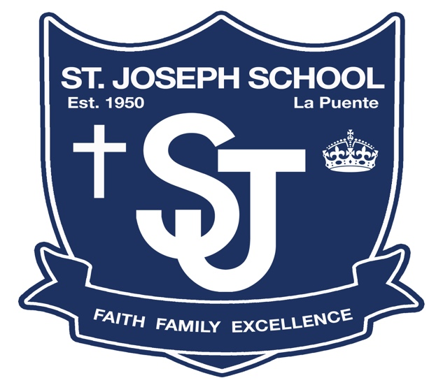

Colors: Royal Blue and White

Royal Blue for our Blessed Mother and represents the virtue of loyalty.

White is for St. Joseph and represents the virtue of purity.

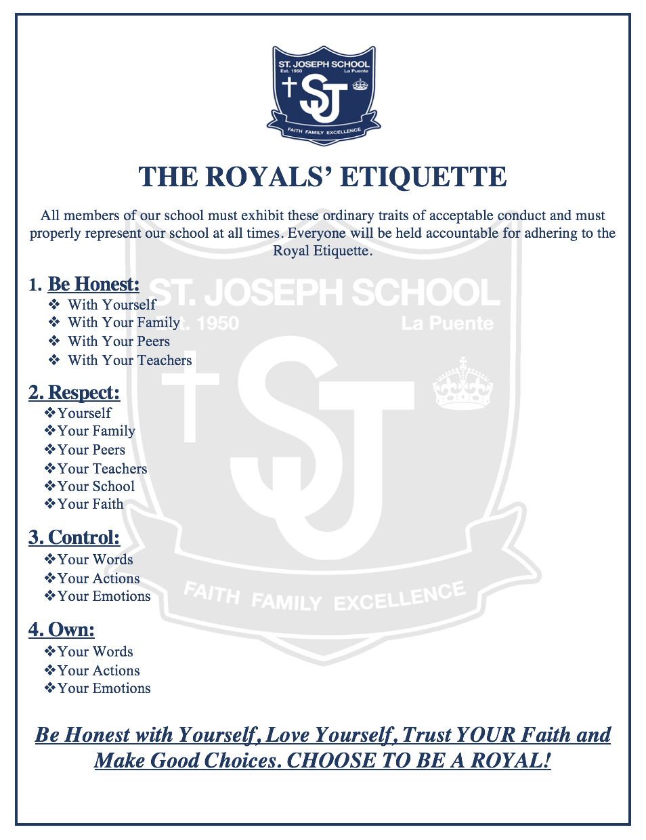

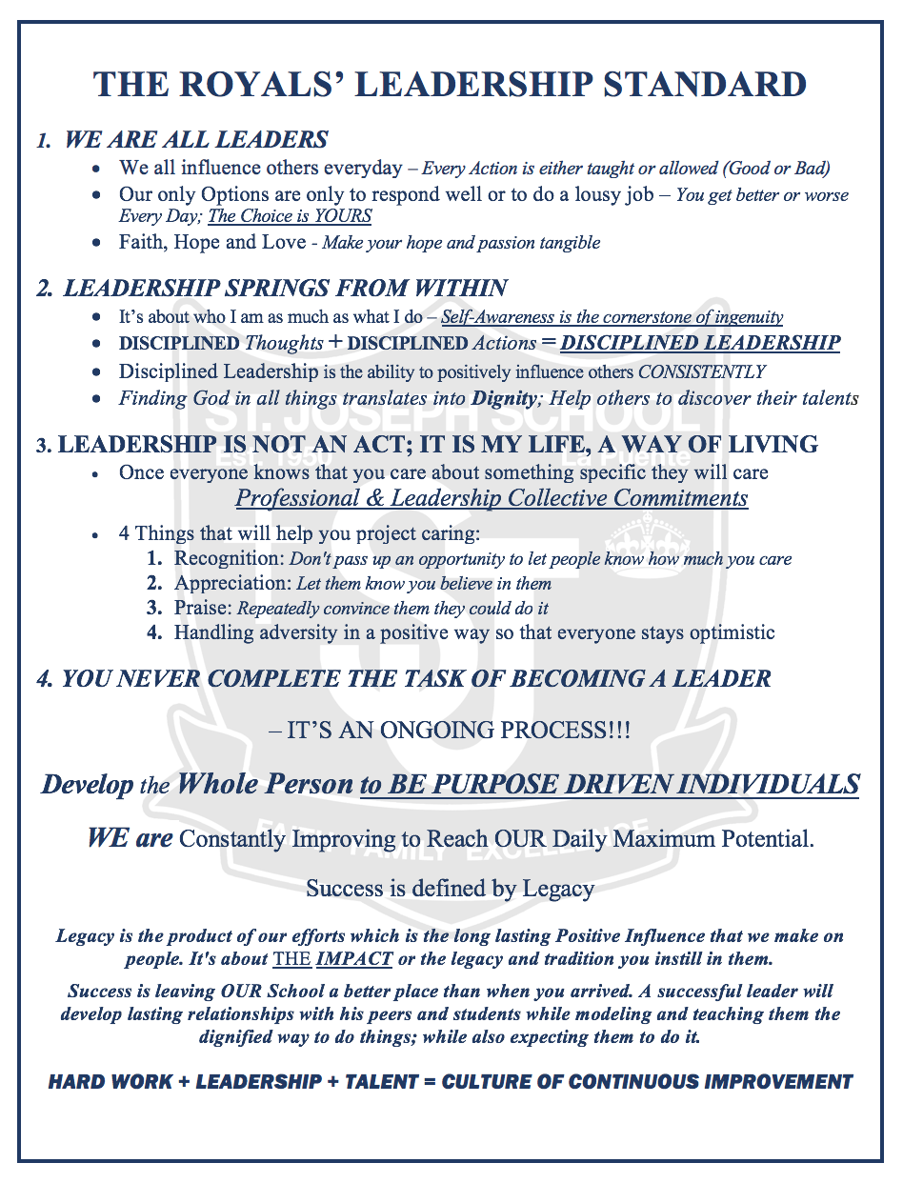

School Schedules
Regular Schedule (Monday – Thursday)
7:25a.m. – 7:30a.m. Daily Faculty Meeting/Prayer
7:30a.m. – 7:45a.m. Morning Traffic Supervision
7:45a.m. – 7:50a.m. First Bell for Line-Up/Daily Morning Assembly Begins
7:55a.m. – 8:00a.m. Second Bell. Students Dismissed. Classroom Instruction Begins
9:45 a.m. – 10:00a.m 1st Recess: TK, Kinder, 1st & 2nd Grade
10:00 a.m. – 10:15a.m. 2nd Recess: 3rd, 4th and 5th Grade
10:15 a.m. – 10:30 a.m. 3rd Recess: 6th, 7th, & 8th Grade
11:30 a.m. – 12:10p.m. 1st Lunch: TK, Kinder, 1st & 2nd Grade
12:00 p.m. – 12:05p.m. School Wide Angelus Prayer
12:10 p.m. – 12:50 p.m. 2nd Lunch: 3rd, 4th and 5th Grade
12:50 p.m. – 1:30 p.m. 3rd Lunch: 6th, 7th, & 8th Grade

2:45 p.m. – 3:00 p.m. Dismissal. Supervision Ends at 3:15 p.m.
Minimum Day Schedule (Every Friday)
7:25a.m. – 7:30a.m. Daily Faculty Meeting/Prayer
7:30a.m. – 7:45a.m. Morning Traffic Supervision
7:45a.m. – 7:50a.m. First Bell for Line-Up. Daily Morning Assembly Begins
7:55a.m. – 8:00a.m. Second Bell. Students Dismissed. Classroom Instruction Begins
8:45a.m. - 9:00a.m. Children are Escorted to Church for Mass
9:00 a.m. – 10:10a.m Celebration of the Eucharist. Children are Escorted Back to Campus
10:10 a.m. – 10:25a.m TK, Kinder, 1st & 2nd Grade
10:25 a.m. – 10:40a.m 2nd Recess: 3rd, 4th and 5th Grade
10:40 a.m. – 10:55a.m. 3rd Recess: 6th, 7th, & 8th Grade
11:30 a.m. – 11:45 a.m. Students Return to Class to Pack Up

11:45 a.m. – 12:00 p.m. Dismissal. Supervision Ends at 12:15 p.m.
Mass, Confession, Rosary, and Adoration Schedule
Holy Sacrifice of the Mass: 9 a.m. Fridays
Confession: Mondays- Each class has a weekly alternating schedule
Rosary: Second Thursday of Each Month

2020-21 Morning Gate Assignments
Front Office:
- Mrs. Ramirez
- Open after 7:45 a.m. or on rainy days or for special circumstances manned by Mrs. Ramirez

LP Parking Lot
- Mrs. Torres
- Mr. Carmona
- Ms. Acuna
- Open on Rainy Days or for Special Circumstances

LP Park Gate - Entrance 1
- Ms. Silva
- Ms. Galos
- Open on Rainy Days or for Special Circumstances

Kitchen Gate – Entrance 2:
- Closed

Yard Duty
- Mrs. Sanchez
- Mrs. Sahagun
- Mr. Padilla
  - TK & Kinder students will be received in their classrooms by Ms. Contreras and Mrs. Becker

*Morning gate assignments will rotate monthly

On rainy days or for special circumstances teachers will report to their classrooms by 7:45 a.m. and receive their children.

MORNING/AFTERNOON
PICK-UP & DROP OFF

LP PARK
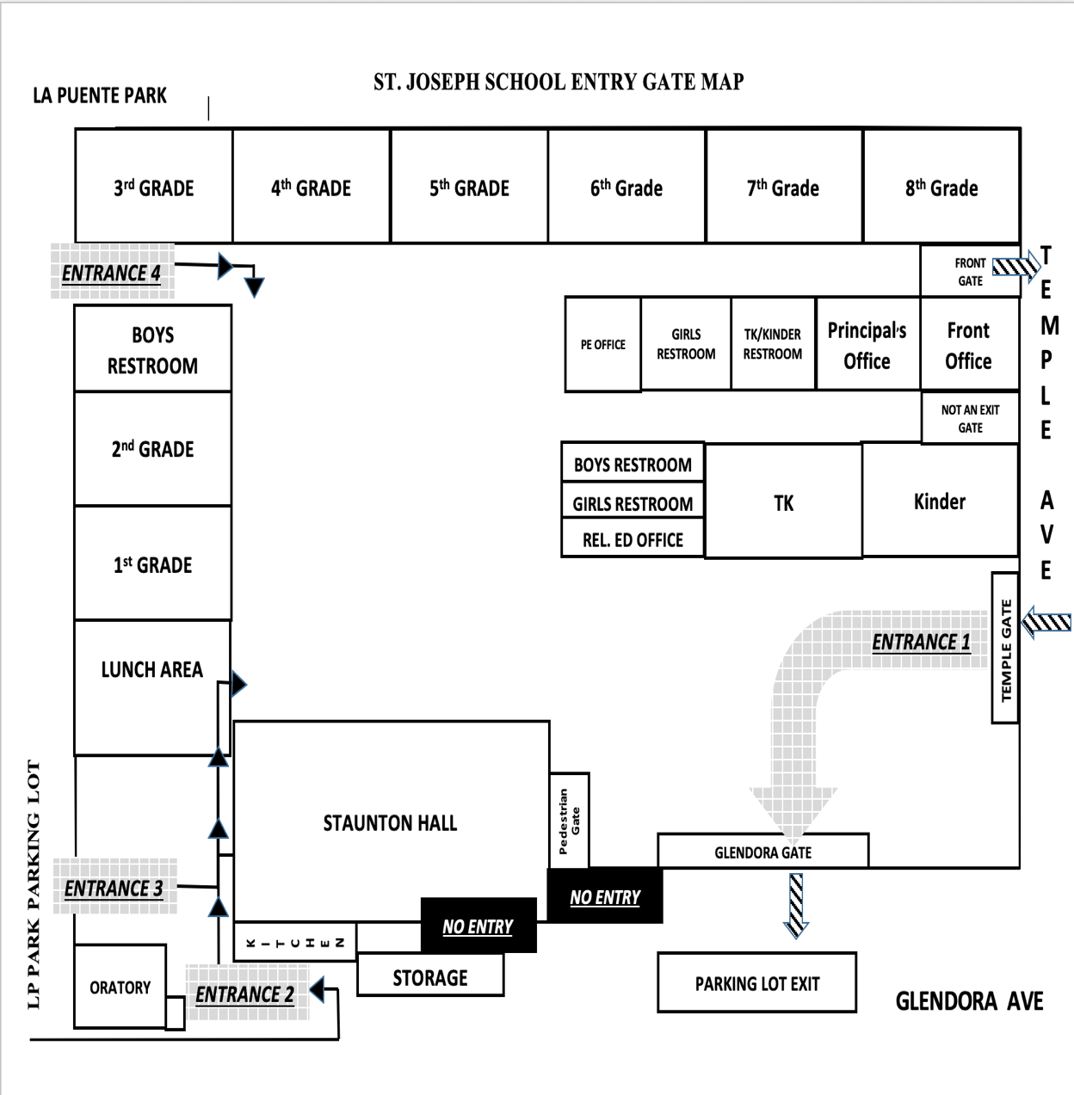
GLENDORA GATE

Teacher Parking
ONLY
Morning Drop Off
7:30am-7:45am

Afternoon Pick-Up

LP PARK
ENTRANCE 1
L
P

R
E
C

CE
N
T
E
R
Glendora Ave.

*Students must enter through the Front Office Gate if arriving after 7:45am

2020-21 School Emergency Safety Teams
Emergency Operations Center
- Incident Commander - Mr. Ranney
- Alternate – Mrs. Ramirez
- Team Members:
  - Mrs. Ramirez
  - Mrs. Silva

Student Control
- Captain – Mrs. Torres
- Alternate – Ms. Galos
- Team Members:
  - Mrs. Sahagun
Sweep
- Captain-Mr. Ranney
- Alternate – Mr. Padilla
- Team Members:
  - Mrs. Contreras (1st)

Parent Control
- Captain – Ms. Acuna
- Alternate – Ms. Contreras (TK)
- Team Members:
  - Mrs. Garcia

First Aid
- Captain – Mrs. Becker
- Alternate – Mr. Carmona
- Team Members:

Facilities
- Captain – Mr. Ranney

School Evacuation Map

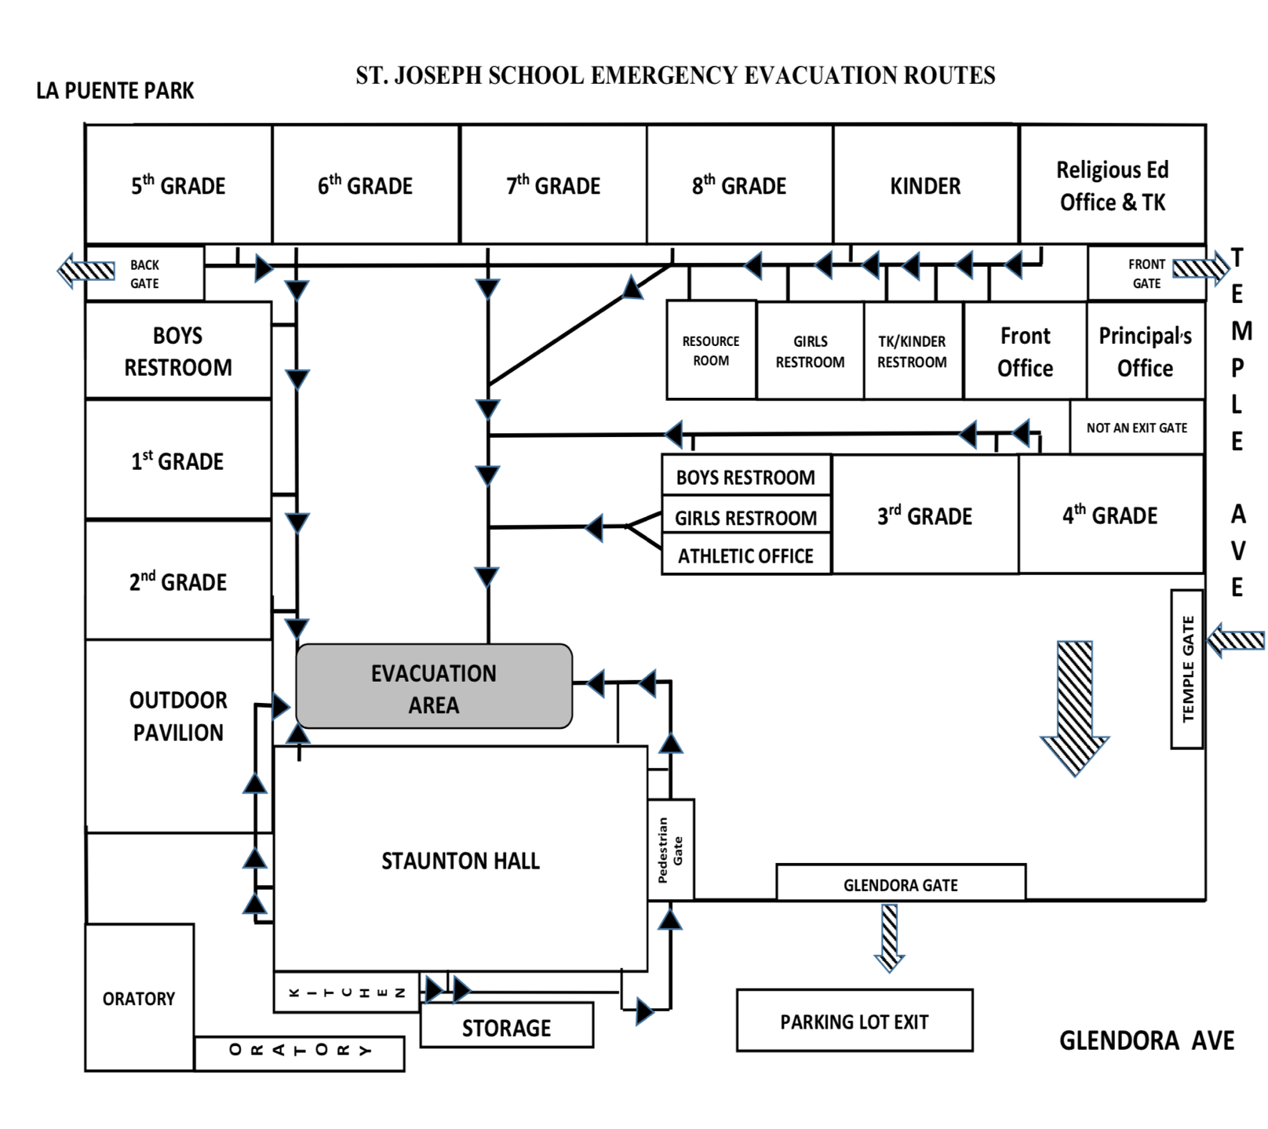
Main
Principal’s
Office
Kindergarten
TK
8th Grade
7th Grade
6th Grade
5th Grade
4th Grade
3rd Grade
2nd Grade
1st Grade

St. Joseph School is in Accordance with Archdiocesan Policies and Procedures
- GENERAL INFORMATION
  - Code of Christian Conduct Covering Students, Parents, Guardians and Other Responsible Adults
The Archdiocese deeply appreciates the choice parents and students make to enroll in its parochial elementary schools and secondary schools. Truly, this is a commitment for life and many families make considerable sacrifices of time and treasure to support their students while they are in school. Often families and students continue this support even after graduation because Catholic education makes a difference. Indeed, Catholic schools are different.
All schools in the Archdiocese are intended to be environments that educate, nurture and support students according to the basic Christian principles of charity and love of neighbor. Everyone involved in the development of children and youth – teachers, administrators, parents, families and friends – are required to behave in accordance with these principles.
Our Christian principles provide that:
- Parents or guardians are expected to work courteously and cooperatively with the school to assist the student in meeting the school’s academic, moral and behavioral expectations.
- Students and parents or guardians may respectfully express their concerns about the school operation and its personnel. However, they may not do so in a manner that is discourteous, scandalous, rumor driven, disruptive, threatening, hostile or divisive.
- Parents, guardians or other responsible adults who insult or abuse school personnel in the presence of other school personnel, students or parents on or adjacent to school premises or at some other place where school personnel are required to be in connection with their assigned school activities, may be asked to withdraw their student from the school.
- Conduct that materially disrupts class work or extracurricular activities or that involves substantial disorder will not be tolerated.

These expectations for students, parents, guardians or other responsible adults include, but are not limited to, all school-sponsored programs and events (e.g., extended care, athletics, field trips, etc.).
The school reserves the right to determine, in its discretion, when conduct is of such a severe nature as to warrant immediate action without warning. The action may include removal of a family and its students from the school.
AT ANY TIME, AT THE DISCRETION OF THE PRINCIPAL, ANY OF THE ABOVE PROCEDURES CAN BE SUPERSEDED AND THE PRINCIPAL MAY WAIVE OR IMPOSE ANY DISCIPLINARY RULE FOR JUST CAUSE.

  - Zero Tolerance Policy
The Archdiocese of Los Angeles will not knowingly assign or retain a priest, deacon, religious, lay person or volunteer to serve in its parishes, schools, pastoral ministries, or any other assignment when such an individual is determined to have previously engaged in the sexual abuse of a minor.
Under the Zero Tolerance Policy of the Archdiocese of Los Angeles, any person guilty of sexual misconduct with a minor under the age of 18:
- May not have any paid or volunteer assignment in any ministry in the Archdiocese, and
- May not volunteer in any non-ministerial activity or event where he or she has any possibility of more than incidental contact or supervisory or disciplinary power over minors.
Any parent or guardian who is a registered sex offender must contact the principal to discuss the requirements in order to assure compliance with the Archdiocese of Los Angeles Zero Tolerance Policy.
As a member of the Archdiocese of Los Angeles community, the school wants to assure that it is in compliance with both Megan's Law and the Archdiocese’s Zero Tolerance Policy.
  - Safe Environment Training for Children and Youth
The school and the parish religious education programs have established ongoing safe environment training programs for students, children and youth. All parents are provided home-based materials to help them understand and support their student's education regarding child sexual abuse. The approved programs include Good-Touch/Bad-Touch® and VIRTUS® Teaching Touching Safety (Mandated September 1, 2006). Good-Touch/Bad-Touch® is being implemented in Grades K-9 in Catholic elementary schools throughout the Archdiocese of Los Angeles. The program is designed to be age-appropriate, to support students in understanding occasions of abuse, and to give them confidence in reporting and asserting themselves in situations where they feel unsafe. VIRTUS® Teaching Touching Safety is a K-12 program being implemented in religious education programs and Catholic schools. This program is a vehicle through which parents, teachers, catechists and youth ministers give students the tools they need to protect themselves from those who might harm them. The Archdiocesan Office of Safeguard the Children works with the schools and Directors of Religious Education in the parishes to establish these programs. Questions concerning Safe Environment Training can be forwarded to the principal.

  - Guidelines For Adults Interacting With Minors At Parish Or Parish School Activities Or Events
Adults acting in a staff, faculty, ministerial or other paid or volunteer position in the Archdiocese are role models who are called to treat each minor with respect and care. Staff members, faculty or volunteers serving either in a paid or volunteer position need to maintain professional relationships with minors whether on or off parish or parish school locations. Please review the following guidelines and sign the “Acknowledgment of Receipt” for the file at the parish or parish school where you work or volunteer.
- Staff members/faculty/volunteers will ensure that minors are properly supervised at all times, thus providing them a safe environment. Minors must be viewed as “restricted individuals” because they are not adults and are not independent
- If staff members/faculty/volunteers who are supervising minors observe a situation where civil law, parish and/or school rules are being violated, they must take appropriate action immediately
- Staff members/faculty/volunteers should always be aware they have considerable personal power because of their ministerial positions. Therefore, they will maintain respectful ministerial relationships, avoiding manipulation and other abuses of power
- Staff members/faculty/volunteers must avoid assuming the role of a “father or mother figure” which may create an excessive emotional attachment for all parties
- Attraction between adults and minors is possible, and care and caution should be taken in all interactions. The parish/school administration should be informed immediately if such an attraction exists. Dating or sexual relationships between a staff member/faculty/volunteer and a minor are inappropriate and unethical. Dating or sexual relationships between a staff member/faculty/volunteer and a minor are unlawful
- Communications with minors (e.g., notes, email and internet exchanges, telephone calls) must be for professional reasons only
- Discussions of a sexual nature must always take place in an appropriate educational context. Sexual jokes, slang or innuendo are inappropriate when interacting with minors
- Staff members/faculty/volunteers will respect confidential information concerning minors or confidential information of a personal nature shared by a minor. However, if a minor shares confidential information that could pose a threat to the minor or to others, the staff member/faculty/volunteer has an obligation to notify the proper authorities
- When staff members/faculty/volunteers are supervising minors or young adults at parish/parish school-sponsored activities, they may not be under the influence of alcohol, may not consume alcohol in the presence of persons under age 21, nor offer alcohol to them
- When a staff member/faculty/volunteer is alone in a room with a minor, the door must be open or there must be clear visibility through windows
- Staff members/faculty/volunteers are to engage in games or sports activities with minors only in the presence of other adults, or in a place openly accessible/visible to others
- Staff members/faculty/volunteers planning parish/parish school events in their homes with minors must have the permission of the parish/school administration. In addition, staff members/faculty/volunteers may not have any minor in their homes without the knowledge of the minor's parent or guardian
- Staff members/faculty/volunteers may not drive minors unless it is to or from a parish/parish school-sponsored activity and may never drive alone with a minor. Driving minors requires parental permission slips that indicate the transportation is by personal vehicle. The parish/parish school administration must approve any use of personal vehicles. Trips involving minors must have a sufficient number of adult chaperones and minors to preclude the appearance of inappropriate personal involvement with minors
- Parent or guardian written permission is required for the publication of a picture of a minor
- Adults are permitted to interact alone with minor(s) only after complying with Archdiocesan policies regarding fingerprinting and safe environment training. They may work with minors only as part of a team if they have not met these requirements

  - Boundary Guidelines for Junior High and High School Youth Working or Volunteering with Children or Youth
To ensure the safety of the children in the Archdiocese of Los Angeles, all youth volunteers, both junior high and high school students, including students who are already 18, who work or volunteer with children/youth in school or parish settings must receive training on these boundary guidelines before undertaking their ministry in the Archdiocese of Los Angeles and must sign a Code of Conduct form to verify that they understand their obligations.
  - Parent/Student Complaint Review Process
Concern for the dignity and rights of each person are intrinsic to the Church’s mission as a true witness to the spirit of the Gospel. Circumstances may give rise to conflicts among students, parents and school staff. All parties are encouraged to use every available means to resolve these conflicts when they occur. However, if the involved parties are unable to resolve their conflicts, families may use the Parent/Student Complaint Review Process for additional assistance. All those participating in the Complaint Review Process are responsible for striving toward reconciliation and shall act in good faith. Legal representation is not permitted at any meeting or mediation of the Complaint Review Process. Any person filing a complaint is to be free from restraint, coercion, discrimination, or reprisal in any form.
1.6.a School Level
- The person bringing the complaint is encouraged to try to resolve the complaint by discussing it with the persons directly involved.
- If resolution is not achieved, the complaint should be discussed with the principal (or the pastor if the principal is the subject of the complaint).
- For elementary schools, if the principal is unable to resolve the conflict, the principal will bring the pastor into the process as appropriate.
- After reviewing the facts and facilitating discussion of the problem the principal will respond to the person bringing the complaint.

1.6.b Department of Catholic Schools Level
- If the complaint is not resolved at the school or parish level, the complaint may be submitted in writing to the supervisor at the Department of Catholic Schools, outlining the concerns and reviewing the local process.
- The supervisor will review the complaint (with such consultation as may be appropriate) in a timely fashion and will endeavor to mediate and resolve the matter.
- However, if no agreement can be reached, the supervisor will make a final determination concerning the resolution of the complaint, based on the application of Archdiocesan and school policies and/or regulations, and communicate that determination, which will be final and binding, in writing to all parties.

  - Parent or Parent-Teacher Organizations
and Consultative School Council
If the school has a parent, parent-teacher organization and/or a consultative school council, those involved are advised that these bodies exist to support the school and are important for the school’s viability, but they have very different functions. Parent, parent-teacher organizations, consultative school councils and their members do not have any authority to act independently on behalf of the school or parish. They are not “agents” of the school or parish and any actions taken must receive the official written approval of the pastor and/or the principal as the case may be.
1.7.a Parent or Parent-Teacher Organizations
The main functions of a parent or parent-teacher teacher organization are to raise funds for the school’s current operational expenses, to promote parental support for the school program, and to increase mutual understanding between school and parents. The membership of the parent teacher organization shall include the pastor, the principal, the parents or legal guardians, and the faculty of the school, where applicable.
Financial operation of a parent or parent-teacher organization shall be governed by the regulations for financial operations as found in the parent or parent-teacher organization bylaws.
1.7.b Consultative School Council
The general responsibilities of the consultative school council are in the following areas: strategic planning; policy development; resource development; institutional advancement; advice and counsel with regard to financial planning, management and reporting; marketing of the school and evaluation of the council’s goals and activities.
The membership of the consultative school council should include the pastor, principal, parents (no more than one-third of the total membership), alumni parents, parishioners, members of the civic and local business community, and area educators. Under Canon Law and Archdiocesan guidelines, the members advise the administrative team (pastor and principal) and cannot make decisions binding for the parish education program without the approval of the administrative team (A Primer on Educational Governance in the Catholic Church, the CACE/NABE Governance Task Force, NCEA, 1998).
The regional supervisor at the Department of Catholic Schools is available to assist and guide schools in the implementation of a consultative school council.
AT ANY TIME, AT THE DISCRETION OF THE PRINCIPAL, ANY OF THE ABOVE PROCEDURES CAN BE SUPERCEEDED AND THE PRINCIPAL MAY WAIVE OR IMPOSE ANY DISCIPLINARY RULE FOR JUST CAUSE.

2. ADMISSION AND ATTENDANCE
2.1 School Student Non-Discrimination Policy
The school, mindful of its mission to be a witness to the love of Christ for all, admits students regardless of race, color, national origin, and/or ethnic origin to all rights, privileges, programs, and activities generally accorded or made available to students at the school.
The school does not discriminate on the basis of race, color, disability, medical condition, sex, or national and/or ethnic origin in the administration of educational policies and practices, scholarship programs, and athletic and other school-administered programs, although certain athletic leagues and other programs may limit participation and some archdiocesan schools operate as single-sex schools.
While the school does not discriminate against students with special needs, a full range of services may not always be available to them. Decisions concerning the admission and continued enrollment of a student in the school are based upon the student's emotional, academic, and physical abilities and the resources available to the school in meeting the student's needs.
2.2 Inclusion Procedures
Through the mission of the Archdiocese, our schools strive to serve children with varied learning needs. All educators in Archdiocesan schools follow “Directions for the Inclusion Process in Catholic Schools: Support Team Education Plan Process (STEP) and Minor Adjustment Plan Process (MAP)”. Parents or guardians who feel that their student may need a minor adjustment to enable him/her to participate in the general education curriculum of the school should consult the student’s teacher and principal to determine how best to meet the student’s needs. Parents or guardians may request the “Disability Discrimination Complaint Review Process” from the principal to address unresolved issues.
2.3 Guidelines for Admission to Elementary Schools
- Preferences are given to active members of the parish
- The recommended age for transitional kindergarten students is four (4) years of age on or before September 1
- The recommended age for kindergarten students is five (5) years of age on or before September 1, but required by December 1
- The recommended age for first grade students is six (6) years of age on or before September 1, but required by December 1, unless waived by the principal
- All students must comply with current California immunization and health requirements prior to enrollment
- The parish school will strive to have Catholic education accessible to as many students as possible, both with its educational programs and financial considerations; however, it may have insufficient resources to meet the educational and financial needs of all students
- The pastor and principal will review a student’s continued eligibility for enrollment in the parish school
- The school establishes its own procedures for admission and enrollment

2.4 Privacy and Access to Records
Maintaining confidentiality is the legal, ethical and professional responsibility of every member of the school community, including students, parents or guardians, teachers, aides, and all other employees. Every member of the school community must respect the privacy of all students, families, employees, the principal and the pastor.
2.4.a Pupil Records
“Pupil records” means any record related to a student that is maintained by a school or one of its employees. It includes health records. It does not include “directory information” or a school employee's informal notes, if the notes remain in the sole possession of the maker and are not made available to others, except to a substitute.
Only the principal, as custodian of the records, authorizes the release of pupil records. Only teachers or administrators charged with pupil oversight have the right to view or use pupil records. A teacher’s aide may view or use pupil records only with direct teacher supervision. Pupil records may be released by judicial order such as a subpoena or a search warrant. In specific cases, such as suspicion of kidnapping, police officers may be given access to records.
Parents and legal guardians of minors have the absolute right to access their child’s pupil records in accordance with the school’s reasonable procedures for providing such access. Parents or legal guardians may grant any specified person written consent to access specifically identified pupil records. In cases of legal separation and/or divorce, California state law gives the custodial parent and a non-custodial parent with visitation rights, the right to access and examine pupil records. However, only the custodial parent may consent to the release of records and has the right to challenge the content of the records and to write responses to information regarding disciplinary action. A non-custodial parent without visitation rights has no right of access to records of any kind.
2.4.b Directory Information
“Directory information” means one or more of the following items: pupil's name, address, telephone number, date and place birth, major field of study, participation in officially recognized activities and sports, weight and height of members of athletic teams, dates of attendance, degrees and awards received, and the most recent previous public or private school attended by the pupil.
The school will, to the extent possible, minimize access to student telephone numbers or personal email addresses, unless the parents or legal guardians consent to broader access. To the extent possible, users should try to minimize access to or distribution of student telephone numbers or personal email addresses, unless the parents of legal guardians consent to broader access
Room parent rosters, class lists, telephone numbers, email address lists or any other personal information about families and students are considered confidential and may be used only for the purposes specified. In no cases should commercial enterprises be given access to Directory Information.

2.4.c Parent Authorization to Use Child’s Personal Information
Whenever a student’s image, name, voice and/or work is to be published or used for non-commercial purposes, including, but not limited to, publicity, exhibits, printed or electronic media broadcasts, student publications, marketing or research, parents must execute the Parent’s Authorization to Use Child’s Image, Name, Voice and/or Work for Non-Commercial Purposes giving permission for such publication.
2.4.d Verbal/Written Confidences
Confidential information may be provided by students or parents or guardians to school employees in many ways. Students may confide in staff verbally, in writing, such as a note or a writing/journal assignment. All school employees are required to respect the verbal or written confidences of adults and students, except in cases where the health or safety of the student or others is involved. If the confidence received relates to a health or safety issue, the pastor, principal or other person in charge or appropriate authorities must be notified promptly, keeping in mind the rights of privacy that apply. Archdiocesan policy on reporting suspected abuse of children or vulnerable adults must be followed when applicable.

2.5 Transfer of Records

2.5.a Student Transfers, Withdrawals and Graduation

Whenever a pupil transfers from one school to another, a copy of the Cumulative Student Report and the original Health Record will be transferred by the former school upon a request from the school where the pupil intends to enroll and a release from the parent or guardian. The original Cumulative Student Report remains at the school.
A record of the transfer, the reason for the transfer, and the name of the school to which the student is transferring or entering after graduation should be entered on the original copy of the Cumulative Student Report and in the Student Attendance Register.
Official transcripts are not given to students or parents. The school grants full credit for all work a student accomplishes up to the time of transfer.
Principals may be required by the County Board of Education to report the severance of attendance by any student.
2.5.b Withholding of Records
Under California law, a private school cannot refuse to provide student records to a requesting school because of any charges, including tuition or fees that are owed by the student or parent. However, the school may withhold from parents or guardians the grades, diploma, or transcripts of a pupil pending payment of certain amounts for damaged property, the return of loaned property or unpaid tuition or fees, in accordance with school policy.

2.5.c Cumulative Pupil Record
Full and accurate records, including standardized test results, of each student are entered on the official archdiocesan Cumulative Student Record form and are kept on file permanently. Only authorized personnel have access to these records. Health records are maintained in a separate file.
- Permanent records cards include only the following information:
- Personal and family data with certification of name, place and date of birth of the student and the name and address of the parent or guardian having custody of the student
- Standardized test data
- Transcript of classes
- Attendance information shall be included
- Record of withdrawal or graduation and place to which any copy of the record is sent
- Verification of or exemption from required immunization through high school graduation

2.6. Absence
Principals and teachers are responsible for checking the regular attendance of all students. Every absence must be recorded on the attendance register and record. Elementary schools record absences according to the instructions on the Student Attendance Register.
If a child is absent, the parent/guardian must telephone the school office each day of the absence before 8:30 A.M. and relate the reason for the absence. A request for a student's homework and arrangements for its pickup must also be made at this time. You are able to leave a message at the school anytime, day or night, to report an absence. It should not be necessary for the office staff to place calls to check on the absence of students. It is the parents'/guardians' responsibility to call the school. When the child returns to school, he/she must bring a written excuse signed by the parent/guardian. The note must include:

Name of student
Date(s) of the absence
Satisfactory reason for the absence
Signature of the parent or guardian
If students fail to bring a written excuse when reporting back to school after an absence, they will be sent to the office to call parents/guardians. An absence note must be received the following school day.
Parents/Guardians should schedule all medical and dental appointments for after school hours. If it is necessary for a child to leave the school for such an appointment, the parent must send a note beforehand with the child stating the type and time of the appointment. The child takes the note to the school office where it is recorded, and he/she then presents the note to the teacher. The parent/guardian must come to the school office at the appointed time to pick up and sign out the child. No child will be allowed to leave the premises unless he/she is signed out and accompanied by his/her parent/guardian.
Before returning to the classroom after the medical appointment, a note from the doctor/dentist must be presented to the receptionist upon arrival at the school or the medical absence will be recorded as an absence.
Excessive absence is considered 10 days per trimester – a total of 30 days per school year. Under these circumstances it is at the discretion of the administration with the teacher to determine issuance of a respective trimester’s Student Learning Assessment.
When the student arrives after recess, he/she is ½ day absent.
2.6.a Absences with Acceptable Excuse
When a student has been absent, a written excuse signed by the parent or guardian is required, and the excuses are kept on file for a period of one year. An acceptable excuse includes illness, attendance at medical or dental appointments, funeral services for family members, quarantine directed by County or City Officials or emergency or special circumstances as determined by the school authorities. Excessive unexcused absences may result in loss of academic credit.
If a child has contracted a communicable disease, all parents/guardians of children in his/her classroom will receive a notice listing the symptoms and proper precautions.
If a child is injured or becomes seriously ill during the school day, the parent/guardian or person designated on the medical emergency card will be notified. Students with a fever of 100° or more may not remain in school. The authorized person must come to the school office and sign out the sick child. No student will be allowed to leave the school grounds unless accompanied by a parent/guardian or designated person listed on the emergency card.
2.6.b Extended Absences
When, for family reasons, parents wish to take their children out of school temporarily, the principal and teacher will discuss with the parents the possible effects of such an absence. If a student is absent for an extended time, (e.g., 15 or more days), official grades may be withheld.
Make-Up Work:
IT IS IMPOSSIBLE FOR ANY STUDENT TO MAKE UP EVERYTHING IN THE CLASSROOM ON ANY GIVEN SCHOOL DAY. THEREFORE, PLEASE BE AWARE THAT STUDENTS, WHEN ABSENT, MISS CRITICAL INSTRUCTION TIME, CLASS PARTICIPATION, AND INTERACTION WITH TEACHERS AND PEERS. THESE LEARNING EXPERIENCES CANNOT BE REPEATED. PARENTS ARE ENCOURAGED TO EMAIL THE TEACHER DIRECTLY TO ENSURE THAT ALL ASSIGNMENTS ARE MADE UP.

2.6 b1. Absences due to illnesses
Students who are absent due to illness are held responsible for any work they may have missed. Students are given one day for every day absent to make up missing assignments. It is the responsibility of the students to make up any work they have missed.
2.6.d Leaving School Early
A student may not leave the school before the regular dismissal time without a written request from a parent or guardian. The request must state the reason for early dismissal.
2.6.e Tardiness
A student is tardy if he or she arrives after the time fixed by the school for the beginning of the morning or afternoon session. If the student comes after the designated time, he or she is marked absent half a day. A record of all tardiness is kept in the attendance register and records.
If students arrive at or after the 8:00 A.M. bell, the parent/guardian, or person responsible for bringing them to school, MUST ACCOMPANY THEM TO THE OFFICE AND SIGN THEM IN. Please note: INSTRUCTION BEGINS AT 8:00 A.M.; late arrival is disruptive to the child’s start of day, and disruptive to instruction already in progress. Ten tardies in a trimester constitute a detention in intermediate and middle school grades. The same policies that apply to academic or behavior detentions apply to detentions for tardiness. Excessive tardiness can lead to suspension.
2.6.f Truancy
A student who is absent from school without an acceptable excuse three full days in one school year or is tardy or absent for more than any 30-minute period during the school day on three occasions in one school year, or any combination thereof, is a truant and shall be reported to the attendance office or superintendent of the public school district.
In the event that the school suspects that a student is truant (absent from school, without an acceptable excuse), the school administration will contact the parent or guardian. If the school suspects that the student is a habitual truant (absent three times in a school year, without an acceptable excuse) and all resources at the school level have been exhausted, the school principal will notify the local public Child Welfare and Attendance authorities.
A student who has been reported once as a truant and who is absent again from school one or more days, or is tardy on one or more days, without an acceptable excuse, will be reported again as a truant to the attendance office of the local public-school district. A student who has been reported as truant three or more times is considered a habitual truant and is subject to dismissal.
If a student has been absent without excuse, and it is impossible to contact the parent or guardian within 24 hours after repeated attempts, the attendance office of the local public-school district, the local police department, Child Protective Services or all of those agencies will be notified.
2.7 Security Procedures
2.7a School Campus

To preserve the academic environment and school security, archdiocesan and parish schools are designated as “closed campuses.” No person may enter the campus unless authorized by the school administration. Visitors must present themselves at the school office if they are seeking information or have business to conduct with the school. A guest badge will be issued depending on the nature of the business. Persons are not admitted to the student areas without identification.
Students, faculty and staff are trained to report anyone on campus without the identification badge. Lunches or any other items for students must be delivered to the school office. Students to be picked up for appointments or early dismissal will be called to meet their parents or other caregivers at the school office.
Skateboards, roller-skates, roller blades, and the like, are not permitted on the school grounds at any time.

Students are always expected to conduct themselves in a way that will show concern for the well-being and safety of other students. On the playground the children are to walk to and from the building and to and from their line-up areas.

Yard Supervisor, teachers and aides supervise the playground at recess and lunch. Yard Supervisor and teacher aides are assisted by parent volunteers during the lunch periods or in the classrooms when weather makes this necessary. Students are expected to respect and obey all those serving in the role of supervision.

Approved games, equipment for these games, and play areas are provided for the students. Equipment or games from home are NOT permitted, nor are any games or other activities that have not been approved by the school. This is to ensure the safety of all the students and encourage interaction within age groups.

MORNING/AFTERNOON
PICK-UP & DROP OFF

LP PARK

Teacher Parking
ONLY
Morning Drop Off
7:30am-7:45am

Afternoon Pick-Up

LP PARK
ENTRANCE 1
L
P

R
E
C

CE
N
T
E
R
Glendora Ave.

*Students must enter through the Front Office Gate if arriving after 7:45am

2.8 Disasters / Emergencies
The faculty and staff are certified for CPR and basic first aid. Fire drills are held monthly, and disaster drills periodically throughout the school year. Students are expected to take these drills seriously, keeping silence and following all directives.

Special Parent Directives in the Event of a Disaster

PARENTS SHOULD:
- Remember that the safest place for your child in an emergency during the school day is in the school itself.
- Remember that schools will not send your children home in an emergency unless school conditions become untenable and then only if dispersal can be done with complete safety.
- Be certain that the Emergency Card and on-line data base (School Speak) is accurate and completely filled out each year and returned to school. Accurate Emergency information is the responsibility of the parents and should be kept up to date as phones and emergency contacts change.
- Make certain that your child understands where to go when an emergency arises en route to or from school.
- Monitor the Emergency Broadcast System for emergency information, and for special instructions regarding schools.
- Be aware of, support, and reinforce emergency procedure information your child receives at school.
- Wait at the STUDENT RELEASE AREA set up in the parking lot to sign out your child.
- Be calm and patient so that orderly and safe removal of all students can be accomplished.

PARENTS SHOULD NOT:
- Call the school so that the phone line will be free for outgoing emergency calls.
- Park cars in such a way that would obstruct the free flow of traffic, especially of emergency vehicles.

2.9 Extended School Day Program
Before School Care

A staff member is provided to care for students who arrive to school between 7:00 and 7:30 a.m. Children are not to be left in any unsupervised area of the parish/school property. Children must go from you to the care of school personnel.

From 7:30 – 8:00 a.m., school personnel provide supervision on the playground area for all students.

After School Care
Boys and Girls Club of America offers an after-school program that is held at the La Puente Community Center. Parents must enroll their child in the club for a minimal fee to be eligible for the services. Their purpose is to supervise those students who have no home supervision during this time. Homework time is given as well as outdoor play and games. It is the responsibility of the student, not the supervising adult, to complete/check homework. If homework is not completed during the time given for it, it must be completed at home.

2.10 Work Permits
Under California law and other relevant laws, a minor student may not work without a work permit issued by the appropriate authority. To obtain a work permit, certain information is required from the student’s school. Information regarding work permits and how to apply is available from the California Department of Education website: www.cde.ca.gov.

The minor/student, after obtaining a promise of employment, must obtain a “Statement of Intent to Employ Minor and Request for Work Permit.” The minor, the employer and the parent or guardian must each complete their sections and submit the completed application to the school. The school will verify the information entered on the application by the minor and parent or guardian and will also examine the student’s records and consult the teacher to confirm the student’s satisfactory academic achievement to date. The student must then submit the form to the “work permit issuing authority.” If all requirements are met, the work permit issuing authority may issue the “Permit to Employ and Work.” The “work permit issuing authority” may be the local public school superintendent, those persons authorized in writing by the public school Superintendent to issue the permit, or a school staff member who has been designated and trained as the work permit issuing authority for the school.
A copy of the signed work permit must be kept in the student’s file.
For additional information and forms see http://www.dir.ca.gov/DLSE/ChildLaborPamphlet2000.html

2.11 Student Accident Insurance
The Student Accident Insurance Program is provided for all full-time students in archdiocesan schools/parish. This program assists only with medical expenses incurred because of accidental bodily injury sustained by students while attending school, while traveling to or from school or while participating in a school sponsored and supervised activity, including school sponsored sport and extended day programs. This insurance supplements any insurance maintained by the parents.
AT ANY TIME, AT THE DISCRETION OF THE PRINCIPAL, ANY OF THE ABOVE PROCEDURES CAN BE SUPERSEDED AND THE PRINCIPAL MAY WAIVE OR IMPOSE ANY DISCIPLINARY RULE FOR JUST CAUSE.

3 ACADEMICS AND CO-CURRICULAR ACTIVITIES
  - Grading Scale:
Grades 3 Through 8
A 90%-100%
B 80%-89%
C 70%-79%
D 60%-69%
F 59% and below

Honor Roll (For grades 3 through 8 only)
1st Honors Roll (All A’s including in Conduct & Behavior while also meeting completing 4 service points per Trimester & 1 Christian Service Hour)
**Students in 3rd & 4th Grade only have to complete 2 Service Points to meet honor roll criteria
2nd Honors Roll (All A’s & B’s including in Conduct & Behavior while also completing 4 service points per Trimester & 1 Christian Service Hour)

Service Club Points (For grades 3 through 8 only):
- Points will be awarded per the following service club:
- Choir (2 Points)
- Student Council (2 Points)
- Decathlon (2 Points)
- Athletics (2 Points)
- Folklorico (2 Points)
- Altar Servers (2 Points)
- Lectors (1 Point)
- Ushers (1 Point)
- Flag (1 Point)
- Graphic Design/ Media Arts (1 Point)
- Ecology (1 Point)
Christian Service Points (For grades 3 through 8 only).
- 1 Point will be awarded for completing approved Christian Service Projects. Students that complete projects may receive credit towards a grade. Conversely if students fail to complete a project, they may lose points towards a grade.

Grades K Through 2
Outstanding 90%-100%
Good 80%-89%
Satisfactory 70%-79%
Needs Improvement 69%-and below

TK
Mastery = 4 90%-100%
Expected Development = 3 80%-89%
Time to Develop = 2 70%-79%
Needs Improvement = 1 69%-and below
  - Tutoring
If a student requires private tutoring or parents wish to have a student tutored in school subjects, the parents are responsible for engaging the tutor and paying all tutoring costs. The school may assist the parents in identifying tutoring resources.
Teachers may not be paid for tutoring students assigned to their classes. The administration may force teachers to tutor students outside of their contracted hours.
A school may arrange with independent contractors or entities, who are not teachers or staff at the school to provide tutoring on a fee basis. Independent entities must have appropriate licenses, agreements for use of the premises and insurance.
All tutors and entities must comply with the procedures and policies of the extended school day program and the Archdiocesan Guidelines for Adults Interacting with Minors at Parish or Parish School Activities or Events.
  - Academic Performance
All St. Joseph Students are expected to meet all the Schools Learning Expectations. Students that are involved in extracurricular activities such as but limited to sports, student council, drama or decathlon teams will not be allowed to participate if they have and D’s or F’s in their most current posting of their grades. The principal reserves the right to allow students to participate if a student shows progress towards improving their academic performance.
- DISCIPLINE
Discipline is essential to Christian development. The purpose of discipline is:
- To shape behavior that creates a positive learning environment
- To develop Christian values, responsibility, and self-control
- To help build a sense of community
- To help students exhibit the school’s core values
- To achieve the school’s Learning Expectations

The faculty has developed expectations for classroom conduct which includes consequences and positive rewards. Procedures and expectations are presented to the parents/guardians on Back-to-School Night. Teachers are available to clarify the expectations any time during the year.
Behavioral expectations are in effect at off campus activities as well as on campus. Any inappropriate actions occurring off campus, in any way related to or affecting behavioral expectations, school activities, and/or the learning process, shall be dealt with as if they had occurred at school.
A serious violation of school or classroom rules may be faced with a detention, suspension, or expulsion. This includes but is not limited to:
- Leaving school grounds during the school day without parent/guardian written permission and office clearance.
- Being in the classroom or Staunton Hall without a teacher or adult.
- Inappropriate behavior or language with or towards any student, child or adult.
(The school is not responsible for students who leave the grounds after dismissal and then return for sports or other activity.)
Parents/Guardians and school personnel will share in the responsibility of necessary action to correct a student’s unwanted behavior. Reasonable effort is made to help a student change inappropriate behavior through alternative means before implementing severe actions. Demerit and detentions are meant to serve as a means of communication to the parents. It is through this form of communication that the parents, teachers and administration can work together to better serve each child.
As the Primary Educators it is the school’s expectation that parents return all documented forms of discipline signed by the parents to the homeroom teacher at beginning of the next school day.
  - Detention

Detention maybe issued if there is a serious violation of school rules or habitual misconduct.
  - Suspension/Expulsion:
  - Suspension and/or expulsion from school are not ordinary punishments. They will be used when other corrective measures have failed or a serious offense is committed. When a student seriously violates any rule or regulation, the parents/guardians and school personnel have a shared responsibility in taking necessary action to correct a student's behavior. Every reasonable effort shall be made to change a student's inappropriate behavior through alternative means before implementing more severe actions such as a suspension or expulsion.
  - The school may suspend or expel a student for continued willful disobedience, habitual profanity, vulgarity, or open and persistent defiance of the authority of school personnel or other supervising adults. Further assault and battery upon a student, teacher, or other supervising adults, whether ON OR OFF SCHOOL PREMISES or while under the authority of school personnel, or any threat of force or violation directed toward these persons at any time or place may also warrant suspension or expulsion. Depending on the severity of the situation, the school or its employees may elect to contact local police.
  - The school may suspend or expel a student who has, on school premises or elsewhere, used, sold or been in the possession of narcotics or other hallucinogenic drugs or substances. Depending on the severity of the situation, the school or its employees may elect to contact local police.
  - The school may suspend or expel a student for misconduct when other means of correction fail to restore proper conduct.
  - The school may suspend or expel a student for inappropriate touching, groping, kissing or any type of physical contact that is not school appropriate. This includes but is not limited to any form of sexual harassment or consensual sexual behavior including touching or kissing. This policy extends to any electronic communication that may have any sexual connotation (implied or explicit), including pictures, screen shots or electronic messages between students.
  - The school may suspend or expel a student who willfully cuts, defaces, or otherwise injures in any way, property, real or personal property belonging to anyone but themselves. Parents or guardians are liable for all damage caused by the student.
  - The school may suspend or expel a student for using or possessing intoxicating liquor while on the school grounds, or elsewhere, when under the authority or direct supervision of school personnel, or when such conduct is otherwise related to school activity or school attendance.
  - The school may suspend or expel a student for possessing or smoking tobacco on school premises or at any school sponsored activity.
  - The school will immediately suspend a student for any weapons violence, ie., using or possessing any weapon, including but not limited to firearms, knives, explosives, or other dangerous objects of no reasonable use to the pupil at school or at a school activity off school grounds; and/or for any verbal, written, e-mailed, electronically text-messaged, etc. threat of any kind. Depending on the severity of the situation, the school or its employees may elect to contact local police.
  - The school may suspend or expel a student for theft or forgery.
  - After three detentions for tardiness within each trimester, a student is subject to a one-day suspension. The school may suspend or expel a student for habitual truancy.
  - The school may suspend or expel a student for any other actions that occur BOTH ON OR OFF CAMPUS which, in the professional judgment of the administration, are gravely detrimental to the moral or spiritual welfare of the school community.
Suspension - Specific Guidelines:
  - Official suspension may occur in various forms depending on the circumstances. The student may attend class but lose the right to participate in any school activity on or off campus. The student will be sent home for the entire period of suspension and is assigned academic work to do at home. He/she is also responsible for all work missed during the time of the suspension.
  - The length of any suspension is left to the discretion of the principal in accordance with the nature of the misconduct and the extenuating circumstances. The suspension may not exceed 5 days at any one time.
  - If an off-campus suspension occurs, the student is responsible for all classwork, homework, and any additional assignments missed and will return all work on his/her return to school.
  - When a student is sent home during the school day because of a suspension, the suspension officially begins the following school day.
  - The student may not participate in or attend any school sponsored activity, including practice, games, tournaments, etc. on the suspension day(s).

Specific procedures include:
  - In no case, shall a faculty member, on his/her own authority, suspend or expel a student. These measures are authorized only by the principal, after consultation with the respective faculty member.
  - The student shall be given an oral or written notice of the charges against him/her, and a fair opportunity to present his/her side of the story. He/she will be made aware that a rule has been broken and that he/she is the one who is responsible for the infraction.
  - In "emergency" situations BOTH ON OR OFF CAMPUS, that constitute a clear and present danger to the lives, safety, or health of students or school personnel, suspension may be imposed immediately, and the parents/guardians will be notified.
  - The gravity of suspension requires that notice be given to the parents/guardians by telephone, or other appropriate methods of communication within a reasonable time. In this notice, the exact length of the suspension period shall be specified and the reason for the suspension clearly noted.
  - A conference with the parents/guardians, student, and appropriate school staff will be arranged if necessary. Failure of a parent or guardian to meet with the administration can result in additional suspension, expulsion, loss of financial aid, and/or may not be offered registration for the following school year.
  - Since the grounds for suspension ordinarily differ only in degree from the grounds for expulsion, the possibility of expulsion or a recommended transfer for continued or repeated misconduct will be clearly stated to the student and parents.
  - Prior to re-admission to class, the student and parent/guardian must be informed regarding a clear plan of action which would avoid the possibility of a second suspension. In this way, the student's progress toward self-discipline shall be clearly monitored by the parents/guardians and the school.

  - Expulsion - Specific Guidelines: Expulsion is an extreme but sometimes necessary disciplinary measure for the common good.
- In certain cases, the gravity of the misconduct, with the discretion of the principal, shall warrant expulsion from the school.
- The pastor will be consulted if there is a final decision to expel the student.
- Full credit shall be given for all work accomplished by the student prior to the time of expulsion. Transcripts and report card will reflect final day of attendance and will also state that the student was expelled.
- A copy of any documentation or records regarding the expulsion shall be kept in the school files and one will also be sent to the Diocesan Department of Education. A copy will be given to the parents/guardians and the pastor.
- There is zero tolerance for the use, possession or brandishing of any weapons or any materials used to bully, harass, or endanger another person. This includes bullying or harassing or endangering through the use of technological devices. Please refer to St. Joseph School’s Bring Your Own Device Acceptable Use Policy.

AT ANY TIME, AT THE DISCRETION OF THE PRINCIPAL, ANY OF THE ABOVE PROCEDURES CAN BE SUPERSEDED AND THE PRINCIPAL MAY WAIVE OR IMPOSE ANY DISCIPLINARY RULE FOR JUST CAUSE.
4.4 School Searches
Students’ legitimate expectation of privacy in their person and in the personal effects they bring to school must be balanced against the obligation of the school to maintain discipline and to provide a safe environment for the school community. Accordingly, school officials may conduct a search of the student’s person and personal effects based on a reasonable suspicion that the search will disclose evidence that the student is violating or has violated the law or a school rule.
School officials do not need a warrant or a parent’s permission to conduct a search of the student and/or the school’s or a student’s personal property, as long as they have a reasonable suspicion that a law or school rule is being or has been violated.
Students do not own their lockers or other school property. Lockers are made available to the student by the school. The student does have some expectation of privacy in his or her locker from other students. However, a student may not exclude school officials if the school official has a reasonable suspicion that a law or school rule has been violated.
A student has a greater expectation of privacy concerning his or her backpack, purse, clothing and other personal effects. A school official who finds it necessary to conduct a search of a student’s backpack, purse, clothing or personal effects, must have a reasonable suspicion that the student is violating or has violated a law or school rule. The student’s parents should be notified of any such search.
An alert from a trained and certified detector dog is sufficient to allow the school official to have a reasonable suspicion and to conduct a search of the student’s locker, car or his or her personal property and effects. In addition to this policy on searches by the school, every student is subject to the Archdiocesan Acceptable Use and Responsibility Policies (ADLA Handbook 10.3) for Electronic Communications concerning cell phones and other electronic devices, whether the devices belong to the school or to the student.
If a student refuses to cooperate in a reasonable search of the school or student property (including electronic devices), the student’s parents and/or the police may be called for assistance or referral.

  - Dress Code/Uniform Guidelines
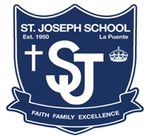
St. Joseph Catholic School
Dress Code/Uniform Guidelines
The SJS uniform is required on all school days, including field trips, unless otherwise authorized by the principal.
There are several important reasons for the uniform code:
- Dress represents religious and cultural values. St. Joseph School, as a Catholic school, cannot allow clothing and accessories that are counter to religious values of modesty, respect for others and for oneself.
- A school uniform provides for justice and equality for among the student body.
- Fashion or cultural trends that come and go often embrace attitudes directly opposed to religious and cultural values. Neatness, cleanliness and simplicity are keeping with SJS values.
- Practical purposes are attained: Good dress encourages good behavior and morale. Looking presentable induces self-respect.
- Social enhancement is achieved: St. Joseph School presents itself to the public as something special, as a religious school with strong values. The proper dress of our students shows a little bit of whom we are to others.
The physical appearance of the student must be neat at all times. It is the responsibility of the parents to see that their child(ren) come to school in the appropriate uniform. Parents and students must abide by the School Dress Code. Please refer to the Jalisco Uniform brochure for grade-specific guidelines and prices. To ensure the proper return of a lost uniform, please write the student’s name on the tags of all uniform items.

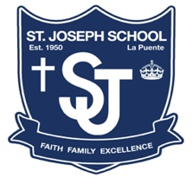
GIRLS DRESS CODE
ACCEPTABLE DRESS | NOT ACCEPTABLE DRESS
SHIRT: White Round Collar with plain white undershirt worn under the blouse for grades TK through 4th  White Blouse for 5th though 8th grade  Grey polo with school emblem with skirt or shorts | No puffy sleeves  No plain grey polos  No polos on Mass days  Please do not wear grey polo under the jumper
SKIRT/JUMPER: Blue plaid jumper | No shorter than 2 inches above the top of the knee
SHORTS: Navy blue walking shorts that touch the knee | No shorts on Mass days
TIE: Criss-Cross tie for all grades
HAIR: Neatly trimmed, combed or braided with hair staying out of the face and eyes – buns/tails acceptable  Hair spray is not allowed at school or in backpacks | No bleached, lighten, dyed, sprayed, or blamed hair  No etched, shaved heads, buzz cuts, corn rows, spiked, mohawks or vertical hair styles
SOCKS: White, black, or navy crew or knee-high socks | No Logos or Emblems, Entire Ankle MUST be covered
SHOES: Oxford, Mary Jane, Saddle Style, or Plain Tennis Shoes. Shoes must be solid navy, black, white or combination of two colors.  Rain boots are allowed on rainy days | No Tennis Shoes on Mass Days or when altar serving  No checkered patterns, lights, wheels, sparkles/glitter or characters on the shoes  No sandals, boots, heals, wedges, open toed, high/mid-top, or converse style shoes
ACCESSORIES: Single pair of stud earring; only one stud in each ear  Simple hair accessories, awarded pins, crucifix, necklace, or scapular  Modest size plaid, navy, black, or white hair bows | No hats, cat ears, or exaggerated hair accessories  No nail polish, make-up, concealer, foundation mascara, eye lashes, lip gloss or lip stick allowed  No nose rings/studs, bracelets, watches, rings, or hoop/dangling earrings
SWEATER: Navy with school emblem  Approved spirit hoodies | No hoodies on Mass days  No plain or non-approved sweaters or hoodies
JACKET: Navy blue with school emblem or approved school spirit jackets or hoodies | No plain or non-approved jackets or hoodies
COLD WEATHER: Navy or black tights/leggings maybe worn under skirt or jumper  Grey or black sweat pants with school emblem or approved school spirit wear | May not attend school in just leggings, joggers, yoga pants or tights
PE UNIFORM
SHIRT: Light blue T-Shirt with school emblem
Spirit shirts may be worn on PE days
SHORTS: Royal blue mesh shorts with school emblem
SOCKS: White, black, or navy crew | No sports emblems, Entire Ankle MUST be covered
SHOES: Athletic or tennis shoes | No checkered patterns, lights, wheels, sparkles/glitter or characters on the shoes

BOYS DRESS CODE
ACCEPTABLE DRESS | NOT ACCEPTABLE DRESS
SHIRT: Grey polo with school emblem  Light blue button-up Oxford | No plain grey polos  No polos on Mass days
UNDER SHIRT: Plain white under uniform shirt | No graphic T-Shirts as undershirts
PANTS: Navy blue docker style uniform pants | No dickies, corduroy, or nylon. No hoodies on pants  Jeans will be allowed on approved free dress days
SHORTS: Navy blue walking shorts that touch the knee | No shorts on Mass days
BELT: Plain black only | No belt buckles
TIE: Navy tie for all grades | No ties with designs, patterns, or non-navy color
HAIR: Neat, clean and evenly trimmed.  Hair does not touch the collar or touch the ear.  Combed so that it stays out of the face and eyes.  Acceptable hair products are balm or gel  Clean Shaven | No bleached, lightened, etched, or dyed hair.  No shaved heads, buzz cuts, buns, tails, corn rows, spiked, mohawks or vertical hair styles  Hair spray is not allowed at school or in backpacks  No facial hair
SOCKS: White, black, or navy crew socks | No Logos or Emblems, Entire Ankle MUST be covered
SHOES: Navy, black or white tennis/athletic, black dress shoes, or Oxford shoes  Shoes must be solid navy, black, white or combination of two colors.  Rain boots are allowed on rainy days | No Tennis Shoes on Mass Days or when altar serving  No checkered patterns, lights, wheels, sparkles/glitter or characters on the shoes  No sandals, boots, heals, wedges, open toed, high/mid-top, or converse style shoes
ACCESSORIES: Simple accessories, crucifix, awarded pins or scapular | No hats, hair bows/ties, or exaggerated hair accessories  No nail polish, make-up, concealer, foundation mascara, eye lashes, lip gloss or lip stick allowed  No nose rings/studs, bracelets, watches, rings, piercings, or earrings
SWEATER: Navy with school emblem  Approved spirit hoodies | No hoodies on Mass days  No plain or non-approved sweaters or hoodies
JACKET: Navy blue with school emblem or approved school spirit jackets or hoodies | No plain or non-approved jackets or hoodies
COLD WEATHER: Grey or black sweatpants with school emblem or approved school spirit wear | May not attend school in leggings, joggers, yoga pants or tights
PE UNIFORM
SHIRT: Light blue T-Shirt with school emblem
Spirit shirts may be worn on PE days
SHORTS: Royal blue mesh shorts with school emblem | No leggings or tights
SOCKS: White, black, or navy crew | No sports emblems, Entire Ankle MUST be covered
SHOES: Athletic or tennis shoes | No checkered patterns, lights, wheels, sparkles/glitter or characters on the shoes

St. Joseph Catholic School
Dress Code/Uniform Guidelines
Additional Guidance

Uniform Shorts/Pants and Skirts
Each item worn must meet this set of criteria:

- Skirts must be no shorter than 2 inches above the top of the knee.
- Shorts must be no longer than the bottom of the knee.
- Pants and Shorts cannot be rolled up at the leg.
- Pants and Shorts must fit the student and cannot be tight or oversized.
- Pants and Shorts must be worn at the waist and may not be low rise.
- Shorts/Pants cannot be cargo-style, denim/jean material or Dickies brand.
- No hats of any type, bandanas, sweatbands or beanies are to be worn on campus.
- Hoods on jackets and sweatshirts may not be worn while the student is in class.
Alternative Dress Day
Alternative Dress is to be worn by students ONLY when authorized by the principal.
Casual/Free Dress - Clothing should be appropriate for school and of a modest nature.

- ACCEPTABLE USE AND RESPONSIBILITY POLICY FOR ELECTRONIC COMMUNICATIONS [“ARCHDIOCESAN AUP”]
All information used in the course of activities for or on behalf of the Roman Catholic Archdiocese of Los Angeles ("Archdiocese") or an archdiocesan school, parish, the seminary, a cemetery, or other archdiocesan department or operating unit (“Location”) is an asset of the Archdiocese and/or the Location, as appropriate. Electronic information and communications require particular safeguards and impose unique responsibilities on all users. The Archdiocese maintains a system of information security to protect our proprietary data. Integral parts of this system are the policies, standards and procedures designed for users. All users must adhere to these policies, standards and procedures for the complete system to remain viable.
These policies, standards and procedures apply to all users of technology, whether adult, child or youth, whether they are paid or volunteer staff, clergy or members of religious orders, in the Archdiocese or in any Location.
These policies, standards and procedures include, but are not limited to, maintaining data confidentiality, maintaining the confidentiality of data security controls and passwords, and immediately reporting any suspected or actual security violations. The Archdiocese prohibits the use or alteration of archdiocesan data and/or information technology without proper authorization. All users have an obligation to protect the confidentiality and nondisclosure of proprietary, confidential and privileged data, as well as personally identifiable information.
  - Definitions
Electronic communications systems include, but are not limited to, electronic mail, telecommunications systems including telephone, voice mail, and video, facsimile transmissions, stand-alone or networked computers, intranets, the Internet and any other communications systems that may be created in the future.
Electronic communications devices include, but are not limited to, regular and mobile telephones (cell phones, smart phones, walkie-talkies), facsimile machines, computers, laptops, electronic notebooks, audio and video equipment, flash drives, memory sticks, iPods®, media players, Blackberries®, and other wireless equipment that may be created in the future.
Electronic communications materials include, but are not limited to, DVDs, CDs, laser discs, audio and videotape, audio and visual recordings, films, microfiche, audio and visual broadcasts, computer operating systems, software programs, electronically stored data and text files, computer applications, emails, text messages, instant messages, and all other downloaded, uploaded, retrieved, opened, saved, forwarded or otherwise accessed or stored content.
5.2 Electronic Communications Systems, Devices and Materials and Users Covered
- All electronic communications systems, devices and materials in the schools, parishes, the seminary, cemeteries, archdiocesan departments or offices, or other archdiocesan operating units (the “Premises”).
- All electronic communications devices and materials taken from the Premises for use at home or on the road.
- All personal devices and materials brought from home and used on the Premises during regular business hours.
- All personal devices and materials, regardless of where they are situated, that are used in such a manner that the Archdiocese and/or the Location may be implicated in their use
- All users of electronic communications systems, devices and materials, including, but not limited to, volunteers, clergy and religious, students, employees, staff or contractors associated with the Archdiocese and/or the Location.

5.3 Ownership and Control of Communications
All systems, devices and materials located on archdiocesan premises, and all work performed on them, are property of Location and/or the Archdiocese. These systems, devices and materials are to be used primarily to conduct official Location and/or Archdiocese business, not personal business.
With permission from the person in charge of the parish (i.e., pastor, priest administrator or parish life director), principal or other person in charge of the Location, individuals may use systems, devices and materials, including access to the Internet, for personal business and web exploration outside regular business hours or during breaks. All users are expected to conform to appropriate content management and web surfing guidelines, whether during or outside regular business hours.
The Archdiocese and the Locations, as applicable, reserve the right to monitor, access, retrieve, read and disclose all content created, sent, received, or stored on Archdiocese and/or Location systems, devices and materials (including connections made and sites visited) to law enforcement officials or others, without prior notice. Any misuse of a school issued device that leads to either soft or hardware damage or repair will result in that user being responsible for the cost of repair or replacement. The school reserves the right to choose who will repair the device.
5.4 Guidelines for Email Correspondence and Other Electronic Communications

- All users of Archdiocese and Location communications systems and devices should use care in creating email, text, video, still images, instant or voice mail messages or in any postings on any social networking site. Even when a message has been deleted, it may still exist on a backup system, be restored, downloaded, recorded, printed out, or may have been forwarded to someone else without its creator’s knowledge. The contents of email and text messages are the same as other written documentation and cannot be considered private or confidential.
- Email and other electronic communications are not necessarily secure.
- As with paper records, proper care should be taken in creating and retaining electronic records for future use, reference and disclosure, as applicable.
- Postings to “All Employees,” “All Parents,” “All Seminarians,” “All Parishioners” and the like on intranets or the Internet must be approved by the person in charge of the parish (pastor, priest administrator or parish life director), principal or other person in charge of the Location before they are sent out.
- Use of personal electronic communications devices and materials during regular business hours should be kept to a minimum and limited mainly to emergencies.
- Archdiocese and Location systems, devices and materials are not private and security cannot be guaranteed. Passwords and user IDs are intended to enhance system security; not to provide users with personal privacy. User account passwords for systems not controlled by a centralized user directory or authentication system must be on record with the person in charge of the parish (pastor, priest administrator or parish life director) principal or other person in charge of the Location.
- User IDs and passwords should not be disclosed to unauthorized parties or shared with other employees, students or volunteers. User accounts are intended to be used only by the assigned party.
- All information systems that create, store, transmit or otherwise publish data or information must have authentication and authorization systems in place to prevent unauthorized use, access, and modification of data and applications. Systems that transmit or publish approved information that is intended for the general public may allow unauthenticated (anonymous) access as long as such systems do not allow unauthorized posting and modification of the published information.
- Any device accessed or used by minors on the Premises must include updated and functioning filters to preclude access to prohibited content. All obscene materials, sexually explicit materials including pornography, and materials that are otherwise harmful to minors or in violation of this electronic communications policy are prohibited and must be blocked. Before allowing minors to access the Internet, a responsible adult must ensure that appropriate content filters are “ON” and functioning.
- Content filters for minors may NOT be disabled or turned “OFF” without obtaining prior permission from the archdiocesan Applied Technology Department or the person with equivalent authority at the location.
- All files downloaded from the Internet, all data received from outside sources, and all content downloaded from portable memory devices must be scanned with updated or current virus detection software. Immediately report any viruses, tampering or other system breaches to the person in charge of the location.
- Critical information should be copied onto backup storage periodically. Backed up information should be stored in a safe place and be available for recovery in case of a loss of the original information. Depending on the complexity of a Location’s information systems, a detailed disaster recovery plan may need to be developed.
- Computer networks must be protected from unauthorized use. Both local physical access and remote access must be controlled.
- Information systems hardware should be secured against unauthorized physical access.

5.5 Prohibited Practices
Users of Archdiocese and Location electronic communication systems, devices or materials and users of personal devices and materials on the Premises under circumstances when the Archdiocese and/or the Location may become implicated in the use may not:
- Violate any federal, state or local laws or regulations.
Violate any rules of conduct, codes of ethics, safe environment or any educational policies, including but not limited to those that apply to communications or the use of information.
- Post or cause to be distributed any personally identifying information about the user or others without permission or review by a responsible adult person, unless required by the user’s job duties or assigned responsibilities. Personal identifying information includes, but is not limited to, names or screen names; telephone numbers; work, home or school addresses; email addresses and web addresses (URLs) of social networking sites or blogs.
- Post or distribute any communications, video, music or pictures which a reasonable person, according to the teachings of the Roman Catholic Church, would consider to be defamatory, offensive, harassing, disruptive, derogatory or bullying. This includes, but is not limited to, sexual comments or images, racial or ethnic slurs, or other comments or images that would offend someone on the basis of race, creed, gender, national origin, sexual orientation, age, political beliefs, mental or physical disability, or veteran status.
- Engage in improper fraternizing or socializing between adults and minors.
- Engage in pirating or unauthorized copying, acquisition or distribution of copyrighted materials, music, video or film; arrange for the purchase or sale of any drugs, alcohol, or regulated substances and goods; or participate in internet gambling.
- Post or send chain letters or engage in "spamming" (sending annoying, unnecessary or unsolicited commercial messages).
- Record any telephone, video, or other conversation or communication without the express permission of the other participants to the conversation or communication, except where allowed by law.
- Use electronic communications devices for designing, developing, distributing or storing any works of programming or software unless required by the duties of the job or assignment.
- Upload, download, view or otherwise receive or transmit copyrighted, trademarked, patented, indecent or pornographic material, trade secrets, or other confidential, private, or proprietary information or other materials to which the user does not have access rights. Regarding copyrighted materials, certain exceptions are given for educational and liturgical purposes. See Archdiocese of Los Angeles Copyright and Video Screening Policy.
- Damage, alter, disrupt, or gain unauthorized access to computers or other systems; e.g. use others’ passwords, trespass on others’ folders, work or files or alter or forward email messages in a manner that misrepresents the original message or a message chain.
- Give unauthorized persons access to Archdiocese or Location systems, provide access to confidential information, or otherwise jeopardize the security of the electronic communications systems (e.g. by unauthorized use or disclosure of passwords).
- Transmit confidential, proprietary, or sensitive information unless the transmission falls within the scope of the user’s job duties or assignment by a responsible adult.
- Introduce or install any unauthorized software, virus, malware, tracking devices or recording devices onto any system.
- Bypass (via proxy servers or other means), defeat or otherwise render inoperative any network security systems, firewalls or content filters.
- Allow any minor to access the Internet on Archdiocese or Location communications devices before a responsible adult has checked to ensure that active filtering of prohibited materials is enabled.
- Use electronic communications devices or systems to transmit any radio frequency signal that is not permitted and/or licensed by the Federal Communication Commission (“FCC”) or that would violate FCC rules or policies.
- Access or manipulate services, networks or hardware without express authority.
5.6 Consequences of Violations of Electronic Communications Policy
Violations of this policy, including breaches of confidentiality or security, may result in suspension of electronic communication privileges, confiscation of any electronic communication device or materials, and disciplinary action up to and including termination of employment, removal from parish or school activities, expulsion from school, canonical review, referral to law enforcement and other appropriate disciplinary action.
6. HEALTH AND SAFETY
6.1 Emergency Card
Each student shall have an Emergency Card that is complete, current, and readily available to the school. The student’s parent or guardian is required to inform the school when there are changes to a home, cell or work phone number or address, the names of persons to notify in case of an emergency, or to any medication prescription for a student. The Emergency Card shall indicate whether or not the parent or guardian gives the school permission to choose a physician in an emergency.
In case of emergency, the Emergency Card will be shown to the paramedics or emergency room staff to authorize treatment, and to advise them if a student has any particular medical needs or is on medication. Therefore, it is imperative that the information be accurate, complete, and up to date.
When a student becomes ill or is injured, the parent or guardian will be contacted immediately. If the parent or guardian cannot be reached, another person listed on the emergency card will be contacted.

Only minor and very basic first aid will be administered to students at school; no secondary treatment, such as changing or removing bandages, will be administered. Parents or guardians will be contacted immediately if there is any question regarding the seriousness of or complications arising from an injury.

No medicine of any kind, including aspirin, may be given to students without written permission from parents/guardians.

Please touch base with the School Office to pick up this form if you have not received/submitted one at this point.

6.2 Examinations and Inoculations
A student, with the permission of the parent or guardian, may be subject to routine tests in school, including auditory, visual, and dental inspection and, upon referral by the principal, to a complete physical examination and/or other professional help.
A tuberculosis patch test and/or X-rays, immunization for prevention of diphtheria and smallpox vaccination may be given only with the explicit written permission of the parents.

6.3 Immunization
All directives regarding immunization, issued annually by the State of California, shall be implemented. No student may be unconditionally admitted to school unless he or she has been immunized against poliomyelitis, measles, rubella, diphtheria, tetanus, pertussis, and varicella for first admission to schools in California. In addition, Hepatitis B immunization is required for students entering preschool and kindergarten. All students entering grade seven are required to present documentation showing the dates when three doses of Hepatitis B and two doses of a measles-containing vaccine have been received. All students entering a California school for the first time must have a Mantoux tuberculosis test.

Medical Exemptions
Under Senate Bills (SB) 276 and SB 714 (Pan, 2019), all new medical exemptions for school and child care entry must be issued through CAIR-ME beginning January 1, 2021. Medical exemptions can only be issued by MDs or DOs licensed in California and must meet applicable Centers for Disease Control and Prevention (CDC), Advisory Committee on Immunization Practices (ACIP), and American Academy of Pediatrics (AAP) criteria.
Starting January 1, 2021:
- Medical exemptions can only be issued through the California Immunization Registry – Medical Exemption website (CAIR-ME) by physicians licensed in California.
- Schools and childcare facilities may only accept from parents new medical exemptions that are issued using CAIR-ME.
A medical exemption filed at a pre-kindergarten facility or school remains valid until the earliest of:
- When the child enrolls in the next grade span (TK/K-6th grade, 7th-12th grade)
- The expiration date specified in a temporary medical exemption
- Revocation of the exemption because the issuing physician has been subject to disciplinary action from the physician’s licensing entity.
Starting January 1, 2021, all new medical exemptions for school and childcare entry must be issued through CAIR-ME. Parents and physicians can register and create an account in CAIR-ME at any time. Once registered, parents can log in to CAIR-ME to request a medical exemption. Parents take the exemption request number to their child’s physician who can log in to CAIR-ME to issue the exemption. Once the exemption is issued, the physician prints the two-page form and provides a copy to the parents to give to their child’s school or child care facility.
Instructions to Request a Medical Exemption | Spanish

6.4 Health Records
Every school must comply with all Health Department requirements. Every school has a Health Record Card for each student enrolled in the school. Upon transfer to another school, the student health records are forwarded with the student’s transcript to the receiving school.

6.5 Medical Appointments
Early dismissal for medical or dental appointments shall be granted when the parents/guardians make a request. Parents/guardians are urged to keep such requests to a minimum and encouraged to make arrangements for care during vacation periods or after school hours.

6.6 Medications
The school will not furnish medications. All medications administered at school shall be provided by parents.
- A release stating the nature of the medication, signed and dated by the doctor and also signed by the parent, must be provided.
- Medications administered at school must be in the original container and labeled. The day’s dosage must be sealed, labeled and have the student’s name attached. It shall be in an appropriate container and kept in the school/nurse’s office.
- The student shall come to the office for medication
- Because of the risk of students sharing medications, students may not carry medication of any kind to be self-administered at school. In the event a student is seriously at risk without an epi-pen or inhaler on his or her person, consideration will be given for a variance.
- Students may not be given medicine prescribed for other family members
- The medication regulations apply to both prescription and non-prescription medications
- Students who are diabetic are allowed to test their blood sugar at school in the health room or office and self-administer medication as necessary. The parent or guardian of a diabetic child must sign the Diabetic Consent Form and other appropriate medication permission forms and return them to the school. All medications must be kept in the school/nurse’s office and appropriately labeled as described above. School employees may not administer injections to diabetic children except in emergencies.

No exceptions will be made to the procedure for medication. If parents/guardians do not provide the completed medication form with the prescribed medication, they will have to come to school and personally administer the medication.

6.7 Communicable Diseases
The school cooperates with the local health officer in measures necessary for the prevention and control of communicable diseases in school age children – Education Code, Section 49403(a).
A student who has been absent from school because of a reported communicable disease must have a permit issued by the Public Health Department, a physician, or a nurse before he or she is readmitted to school.
6.8 Allergies
Some students may have severe, life threatening allergies, such as a peanut allergy. While the school will make reasonable efforts to prevent or minimize an allergic student’s contact with allergens, the school does not promise an allergy-free environment.
6.9 Closed Campus

To preserve the academic environment and school security, archdiocesan and parish schools are designated as “closed campuses.” No person may enter the campus unless authorized by the school administration. Visitors must present themselves at the school office if they are seeking information or have business to conduct with the school. There will be only primary entrance to the school. Parents are to avoid entering the school through the gym or courtyard during school hours.
6.10 Removal of Students from School During School Hours
No agency, organization, or person other than a parent or guardian who has custody, or a delegated school employee is allowed to take a student from the school premises during school hours or immediately before or after school.
Exceptions to this rule may be made only:
- By the parent or guardian, when properly identified
- Upon the written request of the parent or guardian after proper verification
- By properly identified law enforcement officers when an arrest is made
- By properly identified representatives of law enforcement agencies, in case of emergency, as determined by the principal

Legally, the responsibility of notifying the parent or guardian of a student taken from the school by a law enforcement officer or representative of a law enforcement agency rests with the law enforcement officer. However, the principal of the school should also immediately inform the student’s parent or guardian except when a minor has been taken into custody as a victim of suspected child abuse, as defined in Section 11165 of the Penal Code or pursuant to Section 305 of the Welfare and Institutions Code.
6.11 Interview and Removal from School of Students by Police Officers

Police officers have the right during the school day to interview students who are suspects or witnesses. School personnel should not hinder the release of a student to police officers. School personnel are not liable for releasing students for this purpose, or other legitimate law enforcement purposes, which require taking the pupil from the school if they are taken with “proper standard of care” which is defined below.

When a student is taken into police custody and removed from school during school hours, the school will inform the parent or guardian except in child abuse cases and will maintain a record of circumstances involved.

Students can be removed from school during school hours by law enforcement only under the following conditions:

- By properly identified representatives of law enforcement agencies who are making an arrest, with or without a warrant, presenting a warrant for the arrest of a pupil, or taking a student into custody without a warrant
- By properly identified representatives of law enforcement agencies when not making an arrest or taking a child into custody as stated above under the following conditions, with the express permission of the parent obtained prior to the release of the pupil and in cases of emergency, when the parents cannot be reached
- By properly identified representatives of a Child Protective Agency when taking a child into custody

Principals must notify the Department of Catholic Schools if a student is removed from school by law enforcement or Child Protective Services.

6.11.a Interview of a Student During School Hours by a Police Officer

Upon presentation of proper identification to the principal or his or her designee, duly authorized representatives of law enforcement agencies and the child protective agencies in the performance of their official duties shall be allowed to interview students in those cases in which an interview out of school hours is impossible, impractical or would duly interfere with the enforcement of law.

Although the law does not require it, the parent or guardian should be informed by the principal that such an interview has taken place, except upon request of law enforcement. It is the policy of the Archdiocese that an adult, either a parent or guardian or school staff person will be present for any interview unless the student selects otherwise.

Before releasing the student for the interview, the principal must exercise the “proper standard of care” which is to:

- Obtain a business card and confirm the identity and official capacity of the police officer and the authority under which he or she acts in the case of the release of the student to the officer, the reason for such an action
- Child Protective Agency workers may interview for the purpose of their legal obligations to investigate reported child abuse or neglect. Child Protective Agency workers are authorized to assume custody to remove a child from school.

Before a student is taken into police custody and removed from the school during school hours, the school will attempt to inform the student’s parent or guardian. The school will maintain a record of the circumstances involved. In cases of child abuse, parental notification is the responsibility of police officers.

6.11.b Informing the Parent or Guardian When a Student Has Been Removed from School by a Police Officer

While it is the duty of the police officer to notify the parent or guardian of the person taken into custody or placed in detention, the school principal shall take immediate steps to notify the parent or guardian of the minor regarding the release of the student to the officer and regarding the place to which the student is reportedly being taken, except when a student has been taken into custody as a victim of suspected child abuse. Even in the case of child abuse it is the Child Protective Agency’s duty to notify the parent or guardian.

AT ANY TIME, AT THE DISCRETION OF THE PRINCIPAL, ANY OF THE ABOVE PROCEDURES CAN BE SUPERSEDED AND THE PRINCIPAL MAY WAIVE OR IMPOSE ANY DISCIPLINARY RULE FOR JUST CAUSE.

St. Joseph School Parent-Student Policies Agreement Form

Acceptance of Parent/Student Handbook
Our family has received and read the St. Joseph School Parent/Student Handbook. We are aware of, understand, accept and agree to follow the policies and procedures stated in the Handbook. We acknowledge that the school has the right to amend the Handbook during the school year as needed and we agree to follow the policies and procedures as may be added or amended. We understand that we may be asked to withdraw our child(ren) from the school or our child(ren) may not be invited to return the following year, if we fail to fulfill our responsibilities under the Handbook and any additions and amendments that may be made.
ELEMENTARY SCHOOL STUDENT NONDISCRIMINATION POLICY
St. Joseph School, is mindful of its mission to be a witness to the love of Christ for all, admits students regardless of race, color, national origin, and/or ethnic origin to all rights, privileges, programs, and activities generally accorded or made available to students at the school.
The school does not discriminate on the basis of race, color, disability, medical condition, sex, or national and/or ethnic origin in the administration of educational policies and practices, scholarship programs, and athletic and other school-administered programs, although certain athletic leagues and other programs may limit participation and some archdiocesan schools operate as single-sex schools.
While the school does not discriminate against students with special needs, a full range of services may not always be available to them. Decisions concerning the admission and continued enrollment of a student in the school are based upon the student's emotional, academic, and physical abilities and the resources available to the school in meeting the student's needs.
We also agree to comply with the Guidelines for Adults Interacting with Minors at Parish, Parish School, Youth Ministry or Religious Education Activities or Events of the Archdiocese of Los Angeles. As stated in the copy of these guidelines: “All adults working or volunteering with minors are also accountable to follow all policies contained in any other ‘Handbooks’ that the parish/school may use’ (i.e.: Catholic Schools Handbook, Parish ministry handbook, etc.). All adults acting in a staff, faculty, ministerial or other paid or volunteer position in the Archdiocese are role models who are called to treat each minor with respect and care. Clergy/staff members/faculty/volunteers serving either in a paid or volunteer position need to maintain professional relationships with minors whether on or off the parish or parish school locations.” These guidelines are part of the commitment of the Archdiocese of Los Angeles to keep children and youth safe and to provide a role model for all minors under our care. We also acknowledge that we have access to the complete Archdiocesan Administrative Handbook at http://handbook.la-archdiocese.org/
Our signatures below indicate our commitment to fulfill our obligations according to the requirements of the Handbook.
Oldest Student Name: ______________________________________ Grade:_________________
Students Signature: ________________________________________ Date:__________________
Middle Student Name: ______________________________________ Grade:_________________
Students Signature: ________________________________________ Date:__________________
Youngest Student Name(s): _________________________________ Grade(s):_______________
Students Signature: ________________________________________ Date:__________________
Parent Signature: _________________________________________ Date:___________________

